1. What does “carbohydrate” mean?

Carbohydrates are the body’s most important source of energy and are used for building materials and cell communication.

1. Distinguish between “aldoses” and “ketoses”.

Aldoses are monosaccharides that contain an aldehyde functional group, while ketoses are monosaccharides that contain a ketone functional group.

1. Draw the structures of glucose in both linear and cyclic forms.

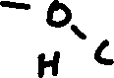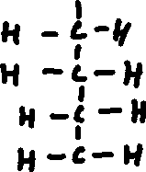

1. What are structural isomers and optical isomers. Give an example of each of them.

* Structural isomers of a compound are compounds with the same chemical formula (same number of atoms of each element) but with a different structure. For example, butane and 2-methyl propane are structural isomers of each other.
* Optical isomers of a compound are compounds with the same chemical formula but have different arrangements of substituents that leave the isomer unable to be superimposed on another isomer. For example, alanine(C3H7NO2) has 2 optical isomers.

1. Show the chemistry involved in the formation of maltose. How is this different from beta linkage?



Maltose is formed through a dehydration synthesis reaction between two alpha-glucose monomers. Beta linkage would require two beta-glucose units, yielding lactose.

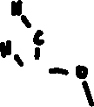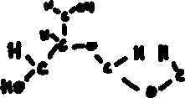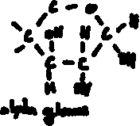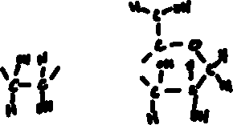

The alpha-glucose monomers bond with an alpha 1🡪4 bond (alpha linkage), forming a spiral shape due to steric repulsion. Beta-linkage would form more of a zig-zag shape due to steric repulsion.

1. Why are polysaccharides insoluble in water?

Polysaccharides are insoluble in water due to their (relatively) large size. Their large size reduces the number of possible locations for hydrolysis, leaving them insoluble in water. The smaller size of monosaccharides and disaccharides leaves them more soluble in water.

1. Where are starch and glycogen normally found in nature?

Starch can be found in all foods made of grains, as well as inside plants that use it to store energy. Glycogen serves a similar purpose in animals, can be found inside our muscles and liver, and is used to provide energy for necessary behaviours like movement.

1. Starch is normally found with two different types of polymers, amylopectin and amylose. How do these polymers differ?

Amylose is a polysaccharide made of lots of glucose units linked by alpha 1,4 bonds in a huge linear, spiralling chain. Amylopectin is made of lots of glucose units that are linked by alpha 1,4 AND alpha 1,6 bonds to produce large branching chains.

1. A. Where is cellulose found?

Cellulose is found within the cell walls of plants to provide structural rigidity.

B. Explain why cellulose cannot be digested in human.

The glucose units in cellulose are connected by beta linkages that form beta 1,4 bonds that we are unable to digest. Other mammals like cows are only able to digest cellulose because their gut bacteria can secrete cellulase to break up cellulose.